Virginia Schrader, Director

409 Eagles Way, North Conway, NH 03860 Phone: 603-356-4370 FAX: 603-356-4373

Conway School Board Report
March 11, 2019

Professional Activities of Staff:
Greg Allain (Marketing) and Alison Bickford (Culinary Arts) are currently taking a Castleton State College course for their certification – Curriculum, Instruction and Assessment in Career and Technical Education. The course teaches how to create effective standards-based CTE curriculum.
On March 22, the CT teachers will spend a full day with educational consultant Kirsten Soroko. She will facilitate a workshop on Curriculum Design and Best Practices. A sampling of topics to be covered are: Creating/Using Rubrics to measure progress; Structuring Class for student centered learning; Curriculum Maps/Competency Alignment; Developing Units using UBD Philosophy; Performance Based Assessment/Assessment Design; Classroom Culture; Best Practices and researched methods of instruction.
Center Priorities:
We are almost finished with our NEASC responsibilities and tasks. Only three of the seven standards need to be reported out and voted on by the faculty. Many thanks to Chris Wong and Joe Riddensdale who have made this process run so smoothly.
In addition to our work with Quality Performance Assessments, CT teachers are also working on providing meaningful feedback to students about their academic and worth ethic performance through individual conferences.
A long term substitute has been recommended for hire and will be presented to the school board for approval on March 11. Steve Arsenault is a retired Machine Tool teacher from Nashua High School and he is excited to help us because he has such high regards for our program. There were no other applicants. Rod Henry and George Abbot, Machine Tool Advisory board members, will continue to work with the advanced students to complete our contract for NASA. I am taking the students on a field trip to the Lake Regional Vocational Center in Naples, ME for their annual Precision Manufacturing Day on March 15. Representatives from Contour 360, Hunting Dearborn, Pratt Whitney and CNC Systems will be there to discuss the myriad of opportunities for careers in their respective companies as well as hands-on demonstrations.

Student and Staff Recognition/Accomplishments:
Robotics (Dan Richardi, Joe Riddensdale):
On February 16th at the state championships in Manchester NH, our Robotics team, 5106C (Chani Mores and Kate Keefe), won the Design Award, due to an excellent Engineering Notebook and overall robot design, to earn a place to compete at the World Championships in Louisville, KY. This event hosts over 500 of the top teams from over 40 countries. The Worlds take place April 24 - 27th and the girls are working hard to refine and perfect their robot for this exciting event. Here is a link to a video that Chani’s father created showing this year’s game and the moment that 5106C (Chani and Kate) received their award from the 15 judges. https://youtu.be/X5k8WFaUDq4 Thank you to Ron Sandstrom, parents and community supporters for making Robotics possible for our students.
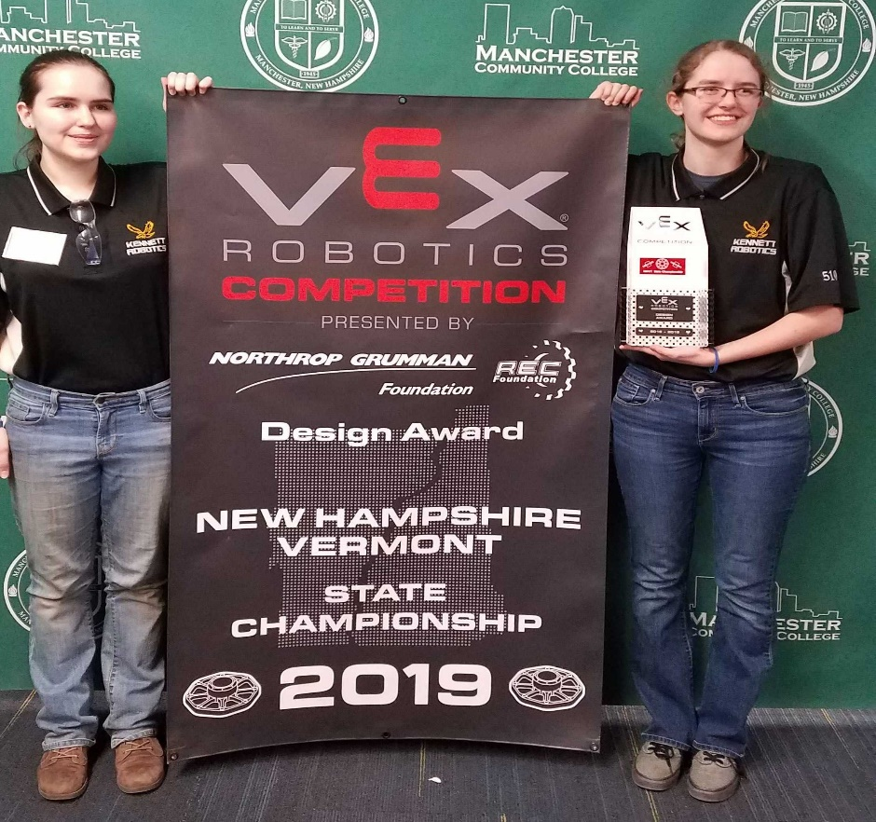

Culinary Arts (Alison Bickford and Mary Donovan):
I will be accompanying the instructors and seven students to the ProStart Invitational Competition in Manchester on March 11. I will present the day’s results to the school board that evening. In the meantime, Hannah Thelemarck, senior, won the teen division in the 9th Annual Cupcake Challenge, sponsored by Mount Washington Valley Promotions. Feast of the Valley, a very special dinner event, produced and hosted by our culinary students and the Key Club will be held on Wednesday, March 27 from 5:30 to 7:30 at KHS. Admission to this amazing feast is $25 per person and helps to support our culinary program. Please see attached flyer for more information.
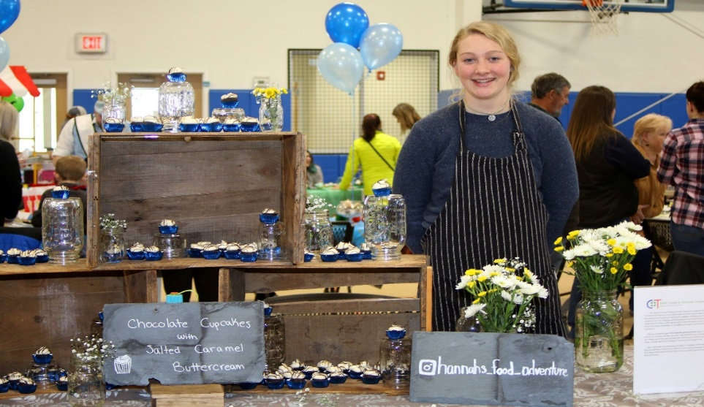

Marketing/DECA (Greg Allain):
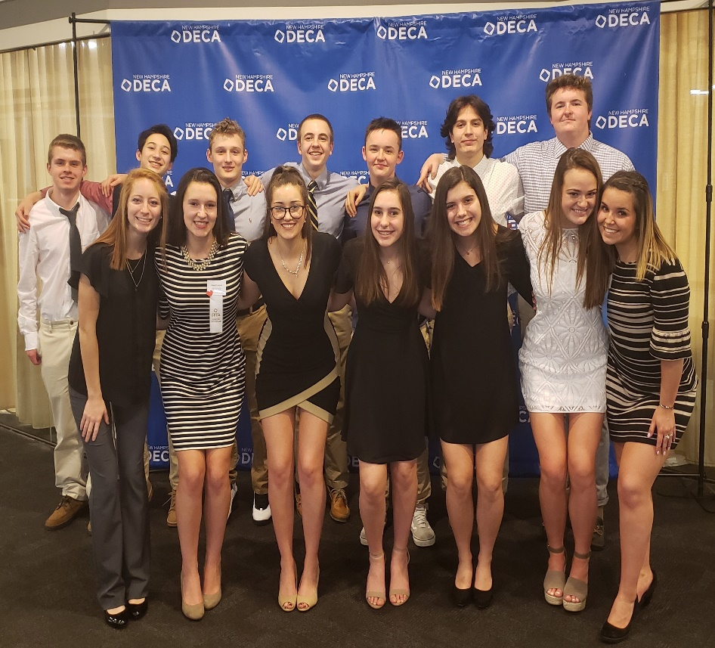
The DECA program had a strong showing at the New Hampshire DECA Conference this year, earning 10 medals overall and had three students qualify for Nationals (ICDC). The conference was held at the Manchester Radisson on February 13-15. Schools from all over New Hampshire were there to compete in various marketing and business categories. There were roughly 500 students competing this year. The competition starts off with a written test that all students take prior to the conference. Both Alex Iannuzzi and Bryce Hill received first place medals for their respective categories. Iannuzzi competed in the Apparel and Accessories Marketing division while Hill competed in the Retail Marketing division. At the competition all students competed in two role plays each where they were given a marketing scenario and allowed 10 minutes to review. They then went in front of judges to give and sell them their ideas. Kennett students received eight medals. “Considering there were 14 students that we had competing, this is very impressive and shows that the students worked tremendously hard preparing,” said Allain. Sam Barrows and Trevor LaRusso received a 3rd place medal in the Sports Marketing team division, Anna Cummings received a 3rd place medal in the Quick Serve division, Sam Pollard received a 2nd place medal in the Automotive Sales division, Hill received a 1st and 2nd place medal in the Retail Marketing division, and Iannuzzi received a 2nd and 3rd place medal in the Apparel and Accessories Marketing division. Hill received first overall in his division, earning a $1000 scholarship to Johnson & Wales University, and Iannuzzi received second overall in her division. The three students that qualified for Nationals (ICDC) were Hill, Iannuzzi, and Cummings.
Teacher Education (Kelley Murphy):
Teacher Education student, Megan Martin, was featured on the front page of the John Fuller newsletter this month. Megan is participating in a school counseling internship with Mrs. Memoli. She works with Mrs. Memoli every other day shadowing and taking part in facilitating the comprehensive school counseling program. Megan plans on attending Plymouth State University to major in child psychology.
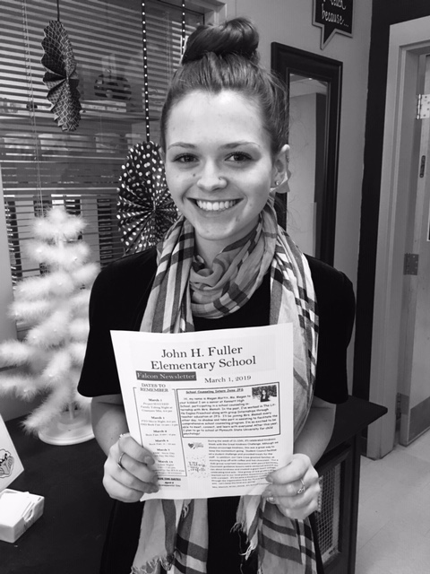

CADD/Engineering (Joe Riddensdale):
Students in engineering class have completed their cover letter and resumes and are awaiting a date for Josh McAllister (HEB Engineers) to come and conduct the mock job interviews. This is an event that we do each year for the level 2 class to prepare them with real world skills.

